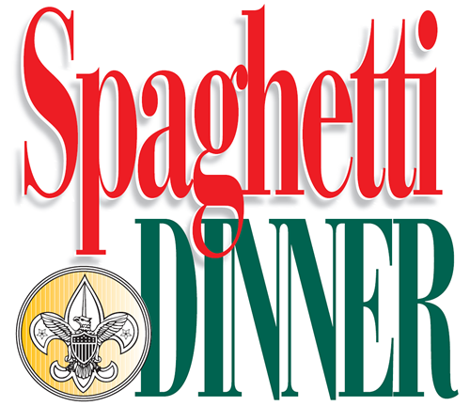
ANNUAL

Saturday, March 14th, 2020
4-7 PM
Level Fire Hall
3633 Level Village Road
Havre de Grace, MD 21078

Adults……………............$12.00
Seniors (60+) …………….$10.00 Children (10 and under) ….....$8.00
All-You-Can-Eat:
Homemade Spaghetti w/Meat Sauce *
*(Marinara Sauce available upon request)
Tossed Salad, Italian Bread, Cake
Iced Tea, Lemonade, Coffee, Hot Tea

Advance tickets Call 443-417-3099 or
E-mail Harvey0622@gmail.com
(Tickets will be available the day of also)

